Test-Style Questions

1. In the circuit shown below, each resistor is 20 Ω. The total current supplied by the battery is 1 A.
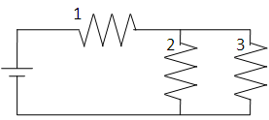
How much power is used in resistor 3?
A 0.938 W
B 20 W
C 3.75 W
D 5 W

2. A 30-W light bulb is plugged into a 120-V source. What is the resistance of the bulb?

A 4.0 Ω
B 0.25 Ω
C 15 Ω
D 480 Ω

3. As additional resistors are connected in parallel to a source of constant voltage, the current in the circuit

A Decreases
B Increases
C Remains the same
D Goes backwards in time

4. A charge of 2 C passes through a 30 Ω resistor in 3 seconds. What is the voltage
across the resistor?

A 120 V
B 6 V
C 20 V
D 60 V

5. In the circuit shown below, each resistor is 20 Ω. The voltage supplied by the battery is 10 volts.
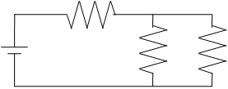
What is the equivalent resistance of the circuit?

A 60 Ω
B 13.33 Ω
C 50 Ω
D 30 Ω

6. Three identical resistors are used in a circuit with a 9-volt battery.
In which of the circuits shown below will the battery supply the least current?
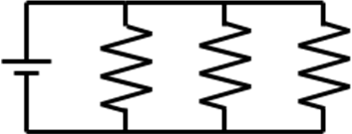

A

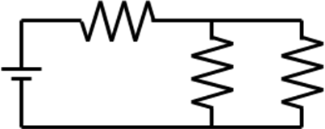

B

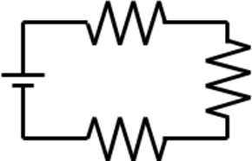

C

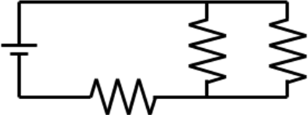

D

7. The ratio of the potential difference across a conductor to the current in the conductor is called
A Conductivity
B Resistance
C Charge
D Power

8. What is the current in a normally operating 60 watt, 240 volt lamp?
A 14400 A
B 4 A
C .5 A
D .25 A

9. How much electric energy will be used by a 120 volt, 30 watt light bulb in 1 minute?
A 1800 J
B 120 J
C 15 J
D 30 J

10. A volt can be defined as 1:
A C/s
B $Ω$/V
C J/C
D N/C

