Electrostatics Study Sheet

In order to be successful on the test, you should be able to:

- Explain where charge originates and that opposite charges attract and like charges repel.
- Appreciate that only electrons move, though protons do feel a force which can be calculated.
- Explain the three ways that charge transfers: conduction, friction and induction and give examples.
- Apply the concept of charge in order to explain various electrostatics situations: attractions of balloons to rods, sticking a balloon on the wall (friction to charge the balloon, polarization in the wall), and how an electroscope works in detail.
- Explain why an electroscope moves when you bring a charged rod close, and why it stays in position when you touch it.
- Calculate the change in force or electric field when the distance and/or charge is doubled, tripled etc. (The inverse-square law questions.)
- Draw and understand electric field diagrams (both lines and vectors).
- Explain the concepts of work (in an electrostatic context), electric potential energy, and potential difference (voltage).
- Explain how energy transfers from one type to another when work is done by an electric field, including charges moving between parallel plates and point charges moving towards/away from each other.
- Explain how and when to apply each equation (parallel plates vs point charges):
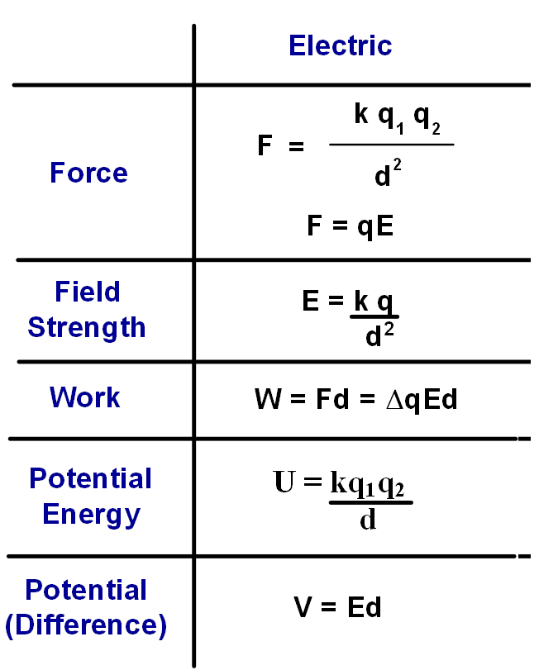
- Combine the forces due to several charges and find the resultant force, including the use of SOHCAHTOA and the pythagorean theorem if needed. (Triangle charges problems, three charges in a line, etc.)
- Combine the electric fields due to several charges and find the overall (net) electric field, including the use of SOHCAHTOA and the pythagorean theorem if needed.

- Understand and be able to complete all the warm-ups, problems, review questions and slides.
- Come in at lunch or after school to check answers and ask questions.

